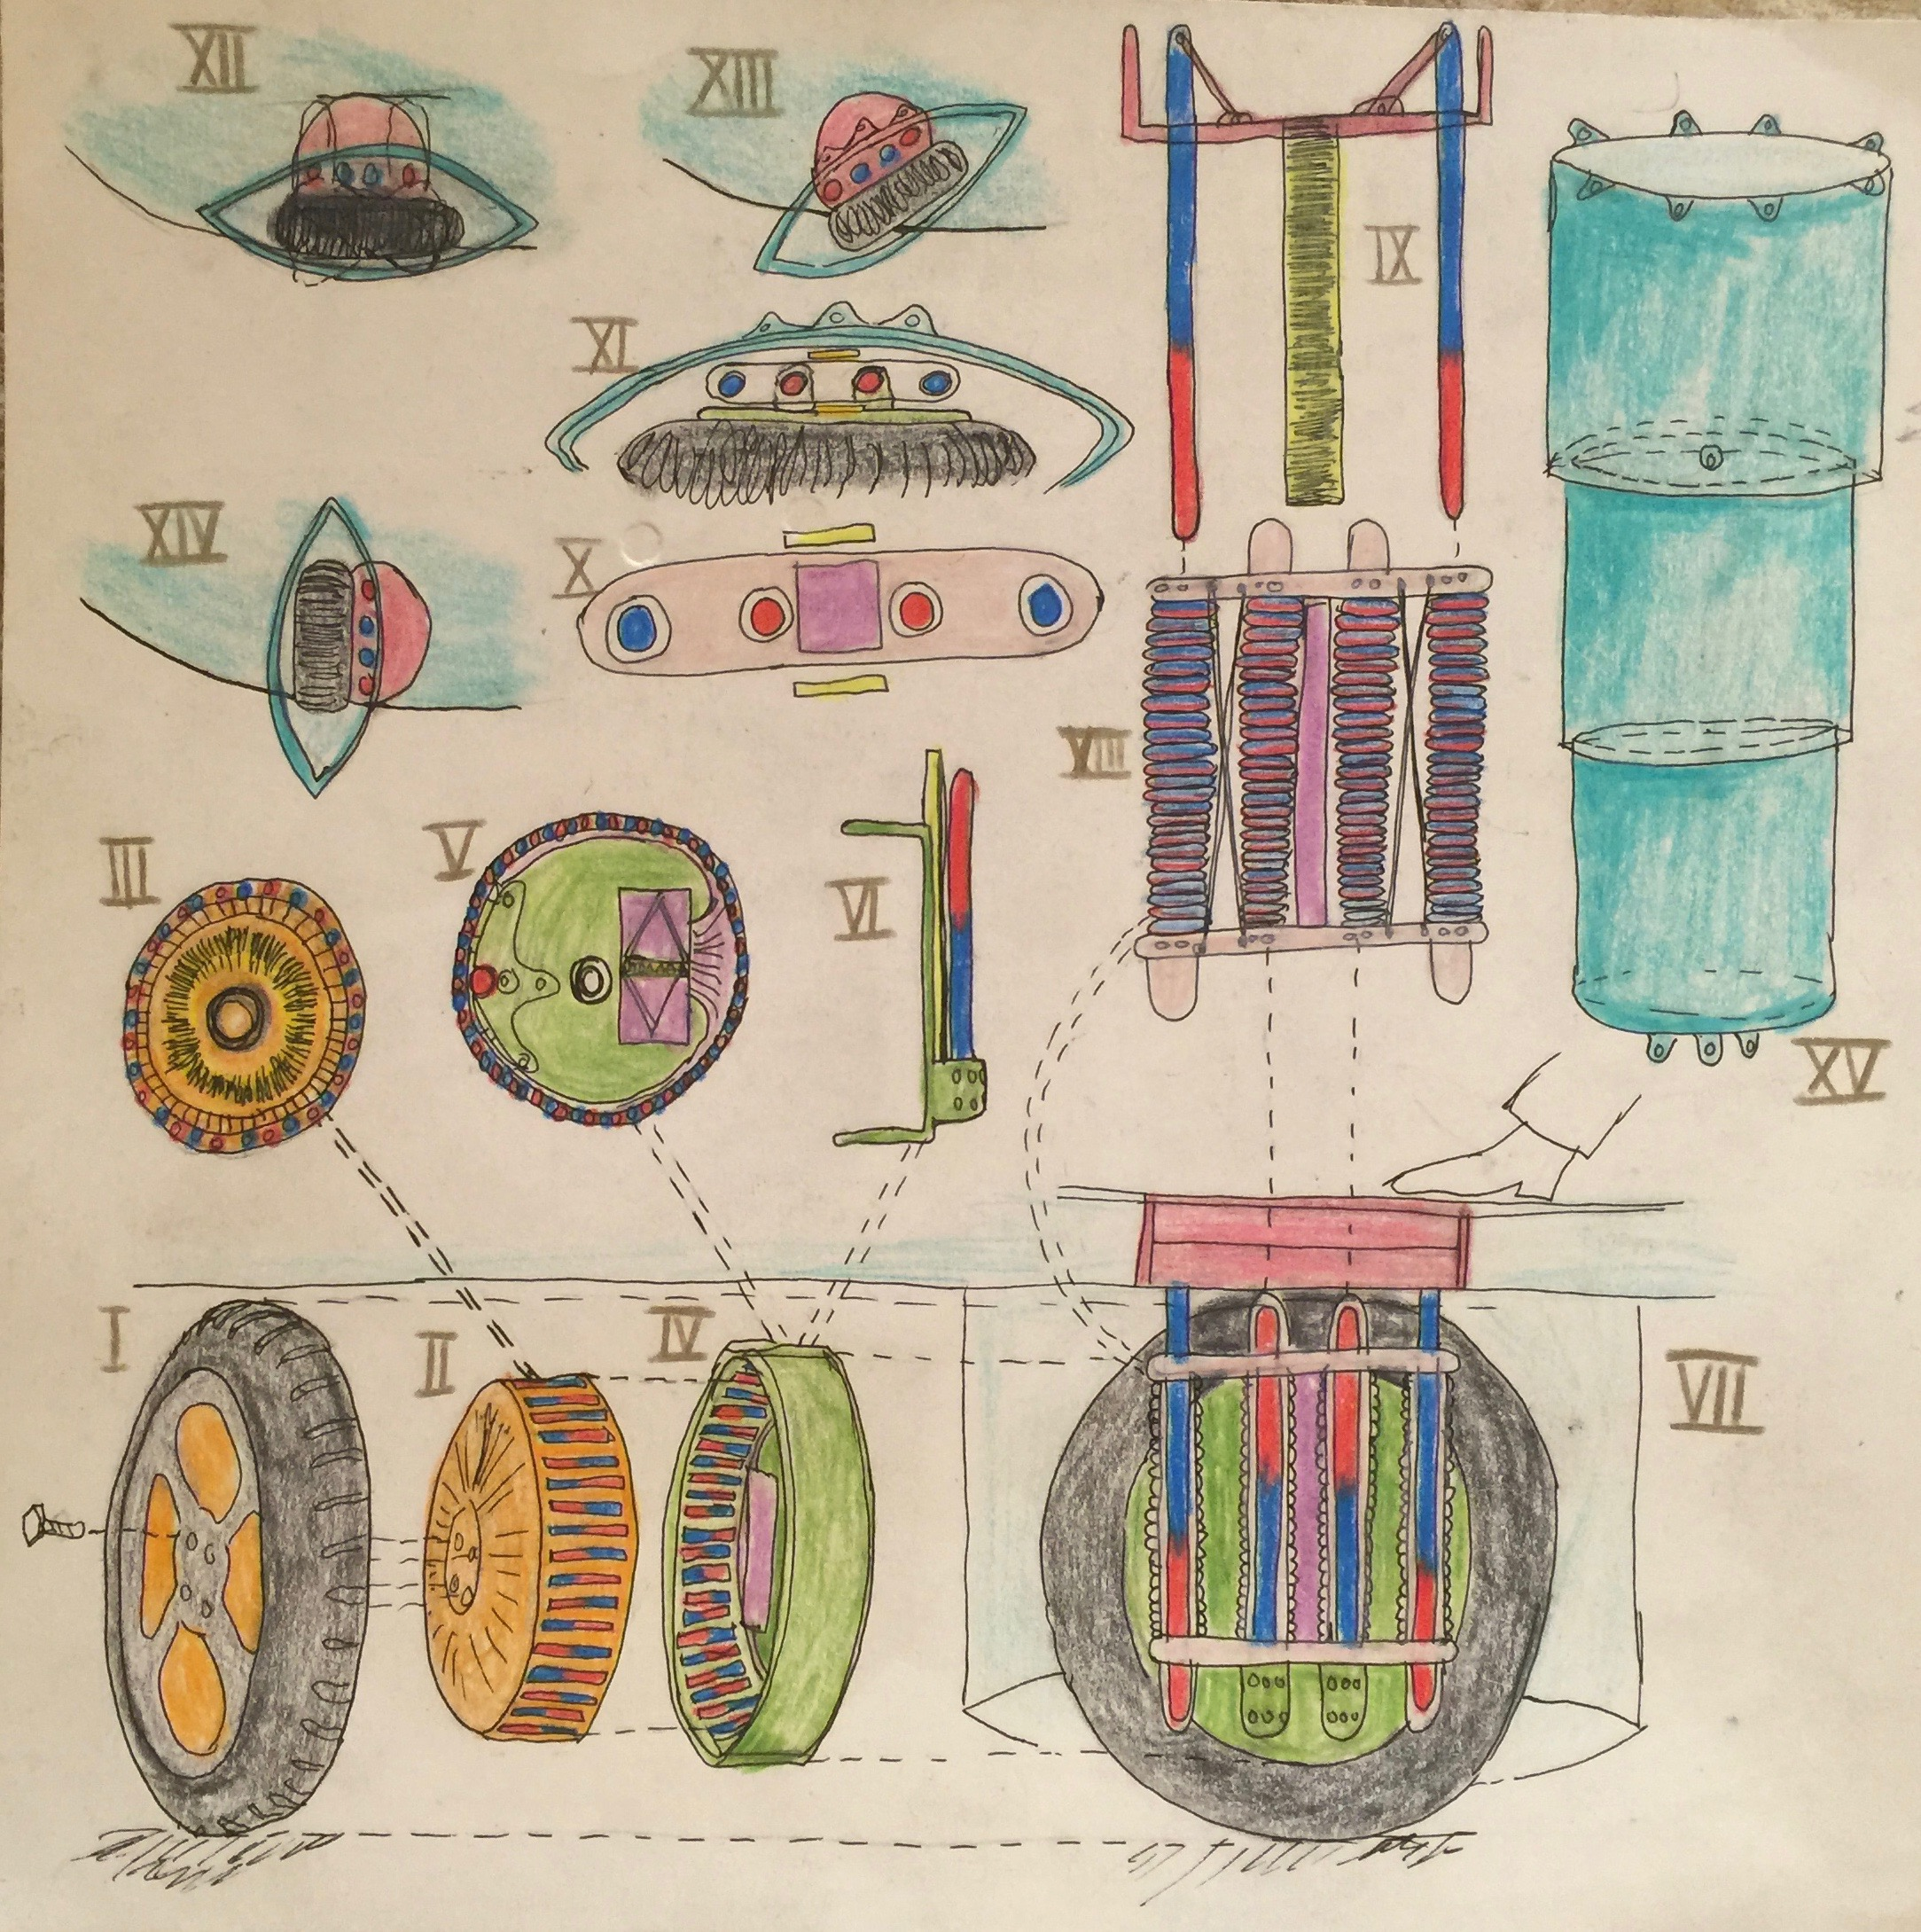Klima Ko-op

Week ending 24 Jan 2016

Wheel Progress Report

# Achieved Mon 18 Jan – Sun 24 Jan 2016

Designed jig to hold metal pieces in place while cutting them with my electric saw. This jig has three parts: end stop, stock support and main body. I’ve designed the OpenSCAD for the first two and 3D printed them, with the first being an almost tolerable print (I since modified the design so am reprinting). I bought the right saw blades. The jig fits my power saw exactly.

Determined how to use household wiring copper wire for detecting all and any non-ball-bearing touch events. The wire on the rotor is not connected to any electronics. It can be threaded through printed holes and twisted tight. The twist can be safely and symmetrically concealed under a spoke attachment point. There will be 12 spokes, as there will be 12 tocuh detection points.

I have been 3D modelling the magnetic circuit. I find it quite charming that this circuit replaced 48 times round a circuit is made up from a hierarchy of files --- and then interestingly, this geometry of 48 circuits is reused three times to subtract space from i) the main body of the stator, ii) the left side of the rotor and iii) the right side of the rotor. What gets subtracted depends on the positioning of space of the circuits array.

About to do

1. Buy
   1. Amp meter – at least 10 amps, if not 20 amps
   2. Insets to screw metal into, and inset into plastic.
   3. Bolts for spokes
   4. Iron stock (saw blade is 1mm wide)
      1. 6mm rod – 100mm. Need 100 x 48 = 4800mm = 5m, call it 6m as the ends are a bit squashed. B&Q.
      2. *12mm square rod – Need 13 * 48 * 2 = 1248mm – I have 2m x 2 is enough.*
      3. 10x3mm rod – Need (121mm * 48) + (14mm * 48 * 2) = 7152mm , ie 8mMetalbits, provided 2m with 8 free cuts of 120mm – need to order 6m more, which I’ll cut. I need to recut all of these at 121mm so that wheel spins symmetrically. Cut up the 120mm ones into 14mm.
   5. Buy More copper wire [4 reels of 20 SWG from Maplin] as pads allow for 3 (not 2) rotations (given the way the main pads have to be at least 11.5mm to provide support for the end pads to stop the rotor falling off sideways).
   6. Buy an SD card to move data from red lap top to 3D printer, to allow it to print off line.

To Do:

* The Y axis of my 3DP appears to slip a tooth from time to time – need to tighten the belt. Or it might have been triggered by the bed touching a cable to the LCD front control pannel.
* Cut all the pieces of Metal using above jig
* Create a 3D printed jig to make it easier to wind the coils using the power drill to provide the rotation.
* Wind the 48 coils with 3 x 100 turns a piece = roughly 15,000 turns. How long will that help. (A friend of ours Debbie has adopted a teenage boy Hamish who is apparently interested to volunteer help – talk to Debbie).
* Learn better how the Arduino software a) measures current and b) controls current. In lieu of a deeper understanding it is pulse width modulation (PWM) control of voltage that in turn controls current. Remember that magnetic fields take time to build and collapse. Measuring current, by default, is with an ammeter.
* Revise max current per battery cell and design protection (using PWM) to ensure that start up doesn’t suck too much current.
* Draw exactly the circuit diagram for Wheel Mark I (consolidating many sketches I have). This diagram is well begun in Omnigraffle. Proceed to precise layout of components on printed circuit boards.

Features in Wheel Mark I

* Traction – runs at 36 volts.
* Photo sensors for position, with Grey’s Disk.
* Manual monitoring of temperature and humidity, by hand (finger tip) only.
* Software: Polled, without delays, without interrupts
* Touch detection to identify if, where and when the stator and rotor touch. Furthermore if they do touch then the software adjusts the PWM to equal the spin.
* Mark I does not attempt to be waterproof, it contains no seals.
* Risks to mitigate
  + Ensure the basics that the motor rotates and pulls.
  + Ensure that rotation is free from rubbing (first mitigation is PWM adjusting pulling across 12 sectors around the wheel).(second mitigation, in extremis would be to add ball bearings, but I want to avoid that).
  + Ensure that the motor pulls the bicycle up a hill OK. The hill linking our lower and higher drives is a good one for testing – and to video!
  + Ensure that the battery is not drained too quickly. Calculate efficiency of energy in and energy out. Clearly the 36v lawnmower battery (and the two sets of 18650 Lithium Ion cells that I have to match the lawnmower battery) won’t have that long a life (they are rechargeable) between charges as they are way smaller than the Zoe’s 22kWh. They are 148 watt hours, which is 150th of the Zoe’s.

Features in Wheel Mark II+

* Waterproof, so that whole wheel can be submersed in a ford and keep working. The milder test is driving through puddles.
* Electronic monitoring of temperature within hub
* Electronic monitoring of humidity within hub (to detect leaks)
* Hall effect sensor to back up photo sensors for position
* Accelerometer
* Interrupt based software, where all 12 touch sensors feed through an OR gate into one interrupt. The interrupt then polls the 12 touch sensors (very quickly) to see which one or ones have touched.

# To Do Next Week

Need to design and implement measurement of volts, amps by electronics and reporting of it from the wheel, up to the Raspberry Pi in-car management computer.

# To Do After That

Insert photos of magnetic circuit in OpenSCAD and steel.

In other news we got another electric car. It’s a BMW i3, which has a much larger motor than the Zoe (about 125 kW) but the same size battery (22 kWh). The car is Liz’s!